Quarterly Business Review SOP

Objective: To deliver a business review session with your client using their portal as a base of knowledge and process that you can use to guide recommendations.

Contents
How to Perform a Business Review for a Client 2
How to Use This Guide 2
Starting the QBR for a Given Client 2
Service Delivery 3
Accounts and Users 3
Infrastructure and Compliance 3
Invoices, Quotes, and the IT Roadmap 4

How to Perform a Business Review for a Client
This guide provides a structured workflow for conducting Quarterly Business Reviews (QBRs) using your client portal. While the portal generally contains all the data you need for effective QBRs, this document organizes the platform's features into a logical sequence that ensures comprehensive coverage of all critical business areas.

How to Use This Guide
Follow the sections in order during your QBR preparation and client meeting:
- Service Delivery - Review support patterns and major incidents
- Accounts and Users - Reconcile licensing and user counts
- Infrastructure and Compliance - Assess hardware, policies, and security
- Assessments – Review manual assessments ran since the last QBR for new initiatives.
- Invoices, Quotes, and IT Roadmap - Discuss budgets and strategic planning
Each section includes specific portal navigation paths and key discussion points to transform raw portal data into meaningful business conversations that demonstrate your strategic value as a technology partner.
Please note that you can change the order to your preference, as well as add supplements to other tools and processes as you and your team see fit.

Starting the QBR for a Given Client
To perform the QBR for a given client, you will begin by doing the following:
- Navigate to Partner > Clients
- Find the client that will have the QBR rendered
- Select the 3 blue-dot menu and select Impersonate Admin
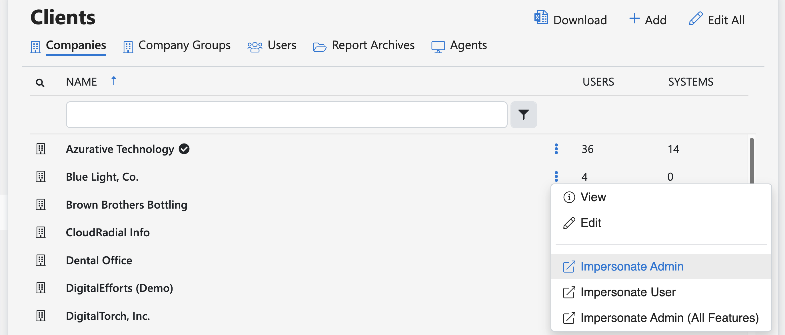
Depending on the features enabled for that client, you can follow the instructions below to get started.

Service Delivery
Goal: Review recurring service challenges, if necessary
- Review the Support > Support Tickets section and look for repeated trouble tickets.
  - You can also check the Closed tab to see if any recurring tickets were closed.
- Review simple ticket statistics via Account > Dashboards > Service (tab).
  - Also, be sure to check the closed tickets for patterns of commonality.

Accounts and Users
Goal: Review number of active emails, users, and licenses for reconciliation
- Counts can be found under Usage > Licenses
  - Full details: https://radials.io/SyncSources

Infrastructure and Compliance
Goal: Review inventory of Endpoints and Servers
- Done via the Infrastructure tab by selecting Endpoints and Servers, respectively.
  - Full details here: https://radials.io/Endpoints and https://radials.io/Servers
Goal: Review policy concerns with relation to compliance
- Use Compliance > Policies to drive discussions based on trouble areas
  - Full details here: https://radials.io/Policies
Goal: Review 3rd-party Reports
- Review reports brought into the report archive folders via Compliance > Reports
  - Full details: https://radials.io/ReportArchives

Assessments
Goal: Review assessments for project work and outstanding efforts
- Review Compliance > Assessments for major initiatives that require a conversation with clients, or to review the pertinent status of an ongoing or recently completed assessment
  - Full details here: https://radials.io/Assessments

Invoices, Quotes, and the IT Roadmap

Goal: Review financial information, if possible, based on supported PSA
- Review outstanding quotes and invoices from Account > Quotes and Account > Invoices
  - These are pulled from the quotes/opportunities in the PSA, if supported. If they’re not in the PSA, CloudRadial won’t be able to see them and display them and you can skip this step (or review it within your own billing system)

Goal: Review the high-level budget and plan for the next 4 quarters
- Review individual planner card under Account > Planner
  - Note that these can be modified to display costs, but if the information for the budget lives in a dedicated budgeting tool, you can skip the budget discussion.
    - Full details here: https://radials.io/Planner

Goal: Account of recurring charges and general company progress
- Review what’s listed under Account > Planner under the “Installed” column
- Pull historical data from older QBRs by way of the Reports
  - You can run reports by creating report layouts first (Partner > Settings > Report Layouts (under Configuration). Then, select the given client under Partner > Clients and select the “Reports” option on the right-hand side of their panel.
    - Full details: https://radials.io/CustomReportTemplates
Goal: Freehand business discussion (Not client portal dependent)
- Discuss what’s in store for the future – Possibly interesting news articles or developments concerning the client’s specific vertical.

